**Chapter 1:**

Download and install Flutter SDK from the [official website](https://flutter.dev/), add it to your system's PATH, install an IDE like Android Studio, enable Flutter and Dart plugins, and run flutter doctor to verify the setup. Actually, it's quite challenging to install Flutter, especially when setting it up; you can't just finish or install it easily.

**Install Flutter**

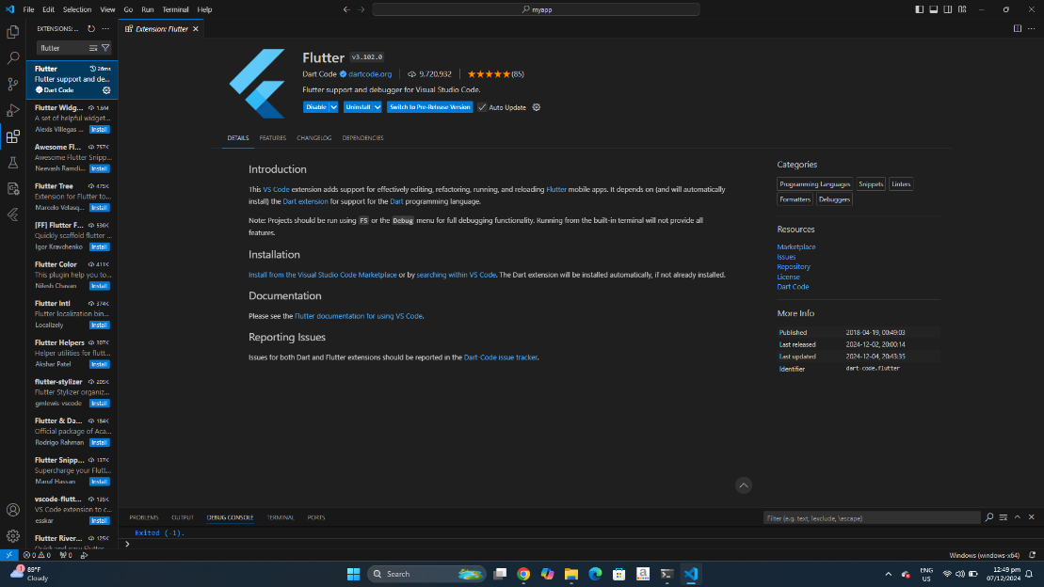

**Install Dart**

